Joint Polar Satellite System (JPSS) Ground Project
Code 474
474-01134

Joint Polar Satellite System (JPSS)
Data Products Engineering and Services (DPES)
Field Terminal Support (FTS) System

User Guide

Goddard Space Flight Center
Greenbelt, Maryland
National Aeronautics and
Space Administration

JPSS DPES FTS System User Guide
JPSS Review/Approval Page

Prepared By:
Shyam J. Vyas
DPES Systems Engineering Integration and Test (SEI&T)

Approved By:
Robert Lutz
Field Terminal Support Manager

Approved By:
Gyanesh Chander
Data Products Engineering and Services Manager

Electronic Approval available on-line at: https://jpssmis.gsfc.nasa.gov/frontmenu_dsp.cfm
--------------------------------------------------------------------------------------------------------------------

Goddard Space Flight Center
Greenbelt, Maryland
Preface

This document is under JPSS DPES CCB control. Once this document is approved, JPSS approved changes are handled in accordance with Class I and Class II change control requirements as described in the JPSS Configuration Management Procedures, and changes to this document shall be made by complete revision.

Any questions should be addressed to:

JPSS Configuration Management Office
NASA/GSFC
Code 474
Greenbelt, MD 20771

Change History Log

Revision | Effective Date | Description of Changes  (Reference the CCR & CCB/ERB Approve Date)
Original

Table of TBDs/TBRs/TBSs

Item No. | Location | Summary | Individual/ Organization | Due Date

Table of Contents
1. Introduction 7
1.1 Scope 7
1.2 Purpose 7
2. Related Documentation 8
2.1 Parent Documents 8
2.2 Applicable Documents 8
2.3 Information Documents 8
3. Overview 9
3.1 Application 9
3.1.1 Inventory 9
3.1.2 Organization 9
3.2 Overview of Operations 10
3.2.1 Contingencies 10
3.2.2 Stopping and Suspending Work 10
3.2.3 Recovery 10
4. Website (Web Portal) 10
4.1 Internet Connection and Access 10
4.2 How to Register 11
4.3 How to Login 14
4.3.1 Login Limits 15
4.4 Website Overview 15
4.5 My Page Customization 17
4.6 Field Terminal Support Project 18
4.7 Repository 18
4.7.1 Manual Downloads 20
4.7.2 Automated Downloads 20
4.8 Search Function 22
5. Account Management 23
6. Additional Resources 23
6.1 NASA Direct Readout Laboratory (DRL) 24
6.2 University of Wisconsin CIMMS CSPP 24
Appendix A (Repository Directory Structure) 25
Appendix B (Abbreviations and Acronyms) 27

List of Figures

Figure 4-1: Screenshot of page when the connection is not private 12
Figure 4-2: Screenshot of the page for accepting the risk 13
Figure 4-3: Screenshot of the landing page 14
Figure 4-4: Screenshot of the registration page 14
Figure 4-5: Screenshot of the page once successfully registered 15
Figure 4-6: Screenshot of account activation email 16
Figure 4-7: Screenshot of the email activation link redirection to the login page 16
Figure 4-8: Screenshot of the post authentication landing page 17
Figure 4-9: Screenshot of the projects page 18
Figure 4-10: Screenshot of the “My Page” page 19
Figure 4-11: Screenshot of the “Personalize this page” page 19
Figure 4-12: Screenshot of the Field Terminal Support overview page 20
Figure 4-13: Screenshot of the repository tab 21
Figure 4-14: Screenshot of the page for manual downloads 22
Figure 4-15: Screenshot of the search box 23
Figure 4-16: Screenshot of the advanced search page 24
Figure 5-1: Screenshot of the account settings page 24

Introduction

The Joint Polar Satellite System (JPSS) includes a High-Rate Data (HRD) antenna that continuously downlinks sensed data as it is collected. Such a downlink is often referred to as a direct broadcast. The Field Terminal Support (FTS) System is a system that provides support to end user processing of direct broadcast data from JPSS-managed satellites (currently, the HRD from S-NPP and JPSS satellites). The FTS system is not an end user processing system, rather it is a support system providing software, data and documentation to both users and system developers to enable them to make use of the direct broadcast data from JPSS managed satellites.

Scope
This document provides website (portal) information for FTS customers, such as customer registration information, a website overview, file availability, and instructions on downloading data. The JPSS Field Terminal Support (FTS) node supports the DB community by providing FTS fundamental processing “building blocks” (software components, data and documentation) using a public web portal. The FTS web portal will also provide the necessary hardware and software specifications and Mission Support Data (including ancillary data, auxiliary data and Mission Notices) needed for processing the broadcasts, as well as making orbital data available to assist the DB community in locating the satellites of interest.

Purpose
The purpose of this document is to support the Field Terminal customers who are accessing data via the FTS System website. It is a comprehensive guide to allow a customer to use and become familiar with the features of the site. DB Customers will be required to procure their own equipment (a local antenna and a remote terminal) which combined with the information provided on the web portal, the DB community can capture and process the HRD content and generate data products, such as Raw Data Records (RDRs), Sensor Data Records (SDRs) and a subset of Environmental Data Records (EDRs).

Organization
Section 1 provides information regarding the scope, purpose, and organization of this document.
Section 2 lists parent documents and related documents that were used as sources of information for this document or that provide additional background information to aid understanding of the interface implementations.
Section 3 provides a FTS overview.
Section 4 describes the system website details.
Section 5 describes management of the FTS system account.
Section 6 provides information regarding the additional resources.
Appendix A (Repository Directory Structure) shows the directory structure.
Appendix B (Acronyms) defines the acronyms and abbreviations used in this document.

Related Documentation
Note: This section is only applicable to customers who have access to he JPSS Management Information System (MIS).
The latest versions of all documents below should be used. The latest JPSS documents can be obtained from URL: https://jpssmis.gsfc.nasa.gov/changes/ccr_view_dsp.cfm?DTTM=20140218133505&RequestTimeout=5000&ri=4269&pv=0
JPSS documents have a document number starting with 470, 472 or 474.

Parent Documents
The following reference document(s) is (are) the Parent Document(s) from which this document has been derived. Any modification to a Parent Document will be reviewed to identify the impact upon this document. In the event of a conflict between a Parent Document and the content of this document, the JPSS Program Configuration Change Board has the final authority for conflict resolution.
Document Number | Title
470-00262 | Joint Polar Satellite System (JPSS) Field Terminal Support (FTS) Requirements Specification Document
474-00594 | Joint Polar Satellite System (JPSS) Field Terminal Support (FTS) Operations Concept Document

Applicable Documents
The following document(s) is (are) the Applicable Document(s) from which this document has been derived. Any modification to an Applicable Document will be reviewed to identify the impact upon this document. In the event of conflict between an Applicable Document and the content of this document, the JPSS Program Configuration Change Board has the final authority for conflict resolution.
Document Number | Title
470-00094 | Joint Polar Satellite System (JPSS) Ground System Security Requirements Document (GSSRD) (Previously 474-00116)
474-00380 | Field Terminal Support (FTS) Services Interface Description Document (IDD)
474-00562 | JPSS Common Ground System Services Interface Definition Document (IDD)
474-00608 | JPSS Field Terminal Support (FTS) Level 4 Requirements Specification Document

Information Documents
N/A

Overview

The FTS Node provides a System that provides a web based Graphical User Interface (Web Site) that uses the Open Source Redmine software framework.

Application
The system is primarily a web portal, consolidating relevant data and information to enable user receipt and processing of the S-NPP and JPSS HRD signals. The FTS Web Portal provides customers access to the following:

- Necessary auxiliary and ancillary data for the processing algorithms,
- Relevant mission status information (e.g., Mission Notices, Mission Schedules and HRD Link Monitoring reports.),
- SDR and EDR processing algorithms,
- HRD/RDR processing software (RT-STPS),
- Relevant program documentation.

Inventory

The following data will be made available via the FTS Web Portal:

- NCEP GFS, NAVGEM and NAAPS forecast files
- NOAA Global Multisensor Automated Snow/Ice Map (GMASI)
- Mission Notices
- Mission Schedules
- Two Line Element Sets
- Revolution Numbers
- Earth Orientation Files
- HRD Link Monitoring Reports
- Ephemeral Processing Coefficient Tables
- Look Up Tables
- VIIRS RSB AutoCal History Auxiliary File
- Algorithm Development Library (ADL) framework and algorithm release packages.
- Global Gridded Intermediate Products (GIPs)
- JPSS Program Documentation

Organization

Please see Appendix B for the specific directory structure showing the organization.

Overview of Operations
The Field Terminal Support (FTS) Node provides functionality to support development and use of processing packages to create JPSS Data Products from the HRD. End users who desire to make use of the HRD signal incorporate such processing packages into an end-to-end system that receives HRD and processes that data into their desired data products. Two organizations were funded to develop processing systems for S-NPP, the NASA/GSFC Direct Readout Laboratory (DRL), which developed the International Polar-Orbiter Processing Package (IPOPP), and the University of Wisconsin’s Cooperative Institute for Meteorological Satellite Studies (CIMSS), which developed the Community Satellite Processing Package (CSPP). These software packages provide a capability for processing locally received S-NPP HRD into SDRs and EDRs, and are installed at user sites across the world.

Contingencies

The FTS Web Portal is designed to maintain a 95% Operational Availability to support direct broadcast users. If the FTS System encounters anomalies, the end users may not notice any errors on the website if the anomaly occurs on the back end. In this case, the website will still be available, however, the latest data may not be present.

Stopping and Suspending Work

If any part of the FTS System is required to stop or suspend work, an email notification will be sent out to registered customers of the Web Portal providing further details.

Recovery

In the event that any part of the FTS System encounters errors or malfunctions that may or may not be visible to users, the Web Portal might not be available for a period of time. Please wait for the website to come back online, if the site is down for a prolonged period and users have not been notified of the outage please send an email to gravite.server@noaa.gov between 9am and 5pm EST for information regarding any issues encountered.

Website (Web Portal) Details

Internet Connection and Access
You must have an Internet connection in order to access the FTS Web Portal.

The FTS Web Portal supports Google Chrome, Mozilla Firefox, and Safari. Microsoft Internet Explorer is not supported.

Please visit the following links:
To access the JPSS Direct Readout Landing Page (where this document is located): http://noaasis.noaa.gov/NOAASIS/ml/jpss-fts.html
To directly access the FTS Web Portal:
https://fts.jpss.noaa.gov

For any issues encountered accessing the website please send an email to: gravite.service@noaa.gov

The service desk is available from 9am to 5pm EST.

How to Register

The first encountered webpage is the landing page (Figure 4-3) below. The FTS website uses Redmine, a flexible project management web application written using the Ruby on Rails framework.

Figure 4-3: Screenshot of the landing page
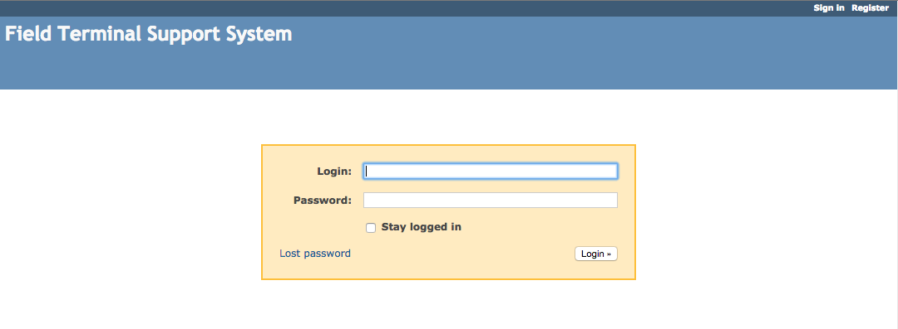

Click the “Register” link on the top right side of the page.

You should see the registration setup screen:

The Register page is used to register a new user. A new user must supply a login name, password, first name, last name, email address and their preferred user interface language.

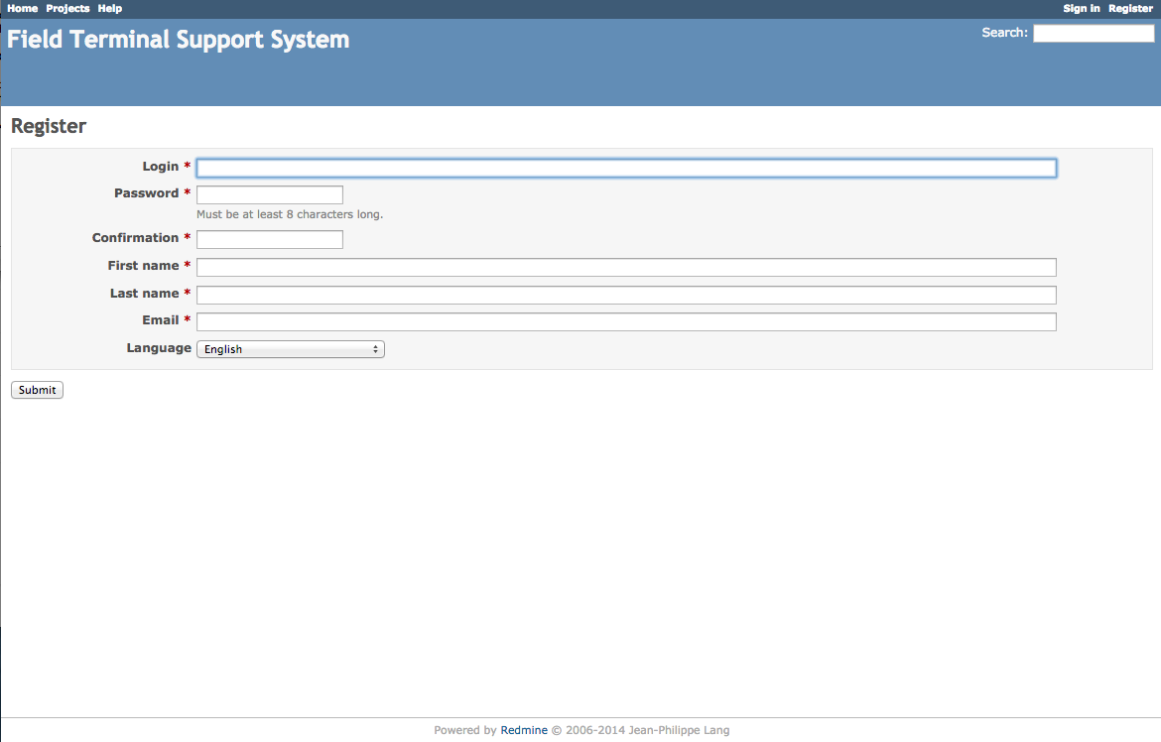
Figure 4-4: Screenshot of the registration page

Provide information for the following fields:

Login: Enter a login name.
Password: Enter a secure password.
Confirmation: Re-type the password.
First name: Enter your first name.
Last name: Enter your last name.
Email: Enter a valid email address (where your registration confirmation will be sent).
Language: Click the drop down to select your preferred language.

If all fields were filled out appropriately, you should see the following screen:

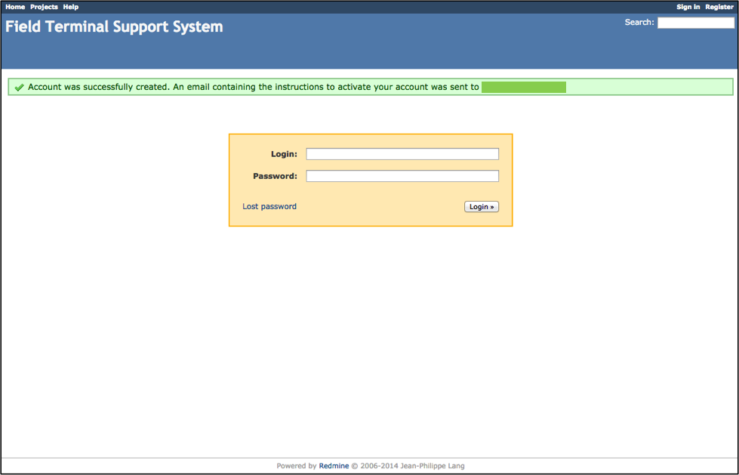

Figure 4-5: Screenshot of the page once successfully registered

Please check your email for account activation (sent to the email address provided at registration)

You should see the following email:

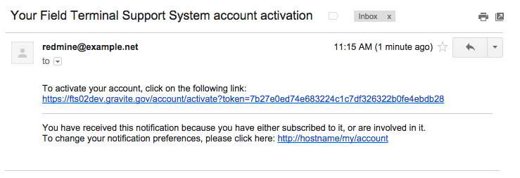
Figure 4-6: Screenshot of account activation email

Please click the link provided in this email to activate your FTS Web Portal account. This will open up a login page within your browser.

Please see Section 6 below for Account Management options.

How to Login
You should see the following webpage:

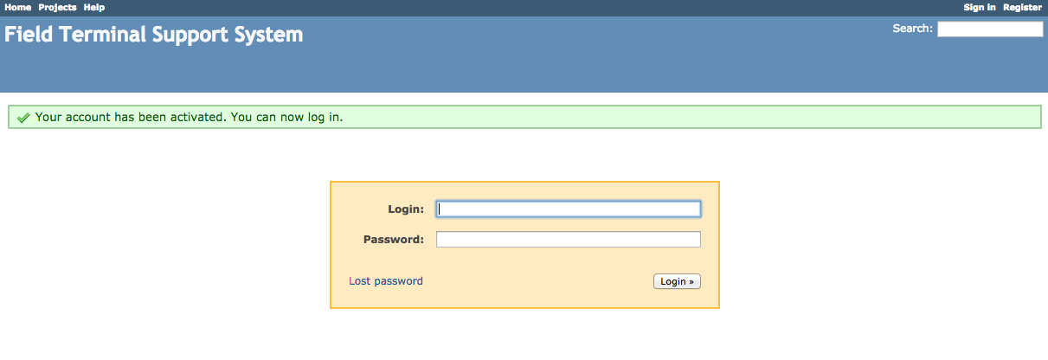
Figure 4-7: Screenshot of the email activation link redirection to the login page

Enter your FTS credentials (login name and password) in the respective text boxes. Click the “Login” button to continue authentication.

If you encounter problems with your FTS credentials, please contact gravite.service@noaa.gov.

You should see the following page once successfully authenticated:

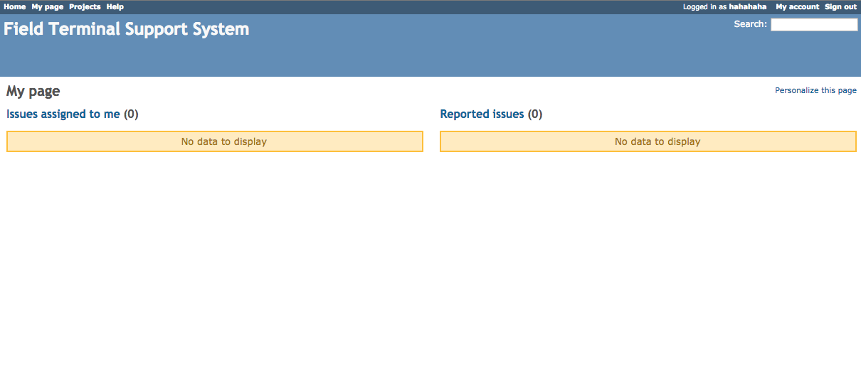
Figure 4-8: Screenshot of the post authentication landing page

Login Limits

When trying to log into the FTS Web Portal, customers have three login attempts. If login is not successful within three attempts, your account will be locked out. The lock out will automatically reset after 30 minutes.

If a password reset is necessary, contact: gravite.service@noaa.gov

Website Overview
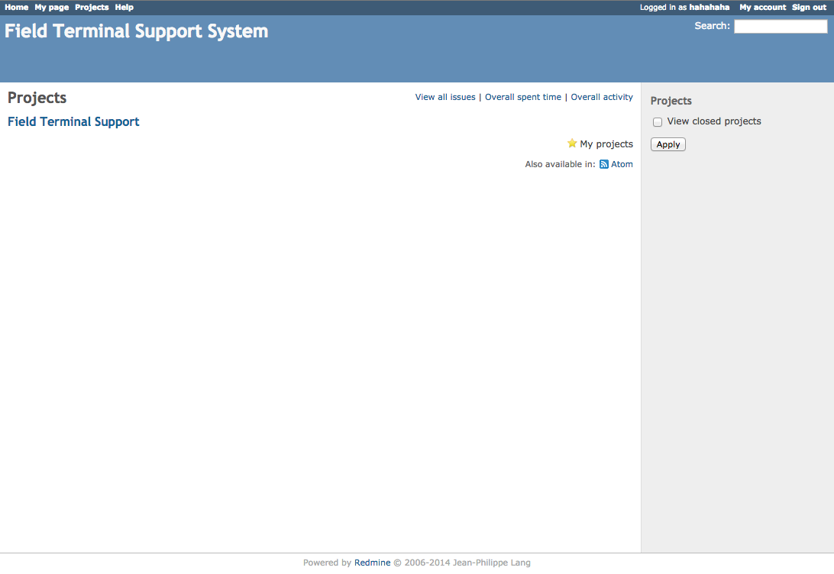

Figure 4-9: Screenshot of the projects page

Menu Links: Along the top of the webpage is the main menu. (From left to right)

- Home – Shows the home page.
- My Page – Shows items related to the customer. This page can be customized.
- Projects – Shows the list of projects that can be accessed.
- Help – Shows the Redmine help page. (External site)
- Username – Shows basic account information.
- My account – Allows the user to change account preferences such as email notifications, time zone, etc.
- Sign Out – Ends the session.

My Page Customization
The “My Page” link along the top left of the webpage provides a customizable view of items in one convenient location.

Figure 4-10: Screenshot of the “My Page” page

Toward the right side of the “My Page” page, a “Personalize this page” link is available for customization.

Via the “Personalize this page” link, specific items can be added and arranged to the “My Page” page, including: Latest News, Documents, Calendar, etc.

Toward the right side of the “Personalize this page” page, a drop down list can be clicked to choose any wanted blocks to be viewable on “My Page”. Clicking the “Add” button will add the specified block to the users “My Page”. Additionally, blocks can be dragged around in this area for organization purposes.

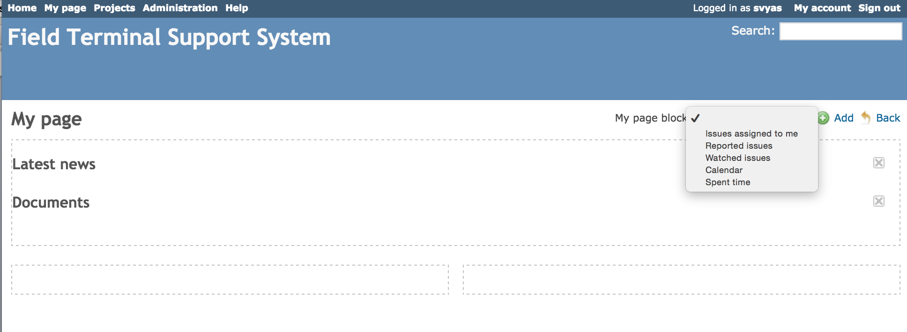
Figure 4-11: Screenshot of the “Personalize this page” page

Once personalizing is complete, click the “Back” button to save and view the updated “My Page”.

Field Terminal Support Project
Click the “Field Terminal Support” Project.

You should see the following overview page:
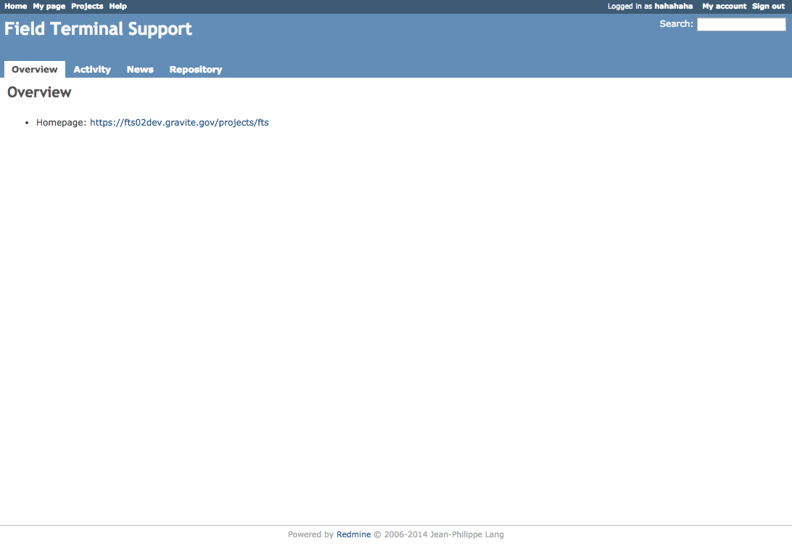

Figure 4-12: Screenshot of the Field Terminal Support overview page

The following is a list of project level tabs (Above from left to right):

- Overview – Provides a high level overview.
- Activity – Shows recent activity by Field Terminal customers.
- News – Shows the latest news about FTS products and availability.
- Repository – Provides access to the FTS data files.

Repository
You will see the following after clicking the “Repository” Tab:
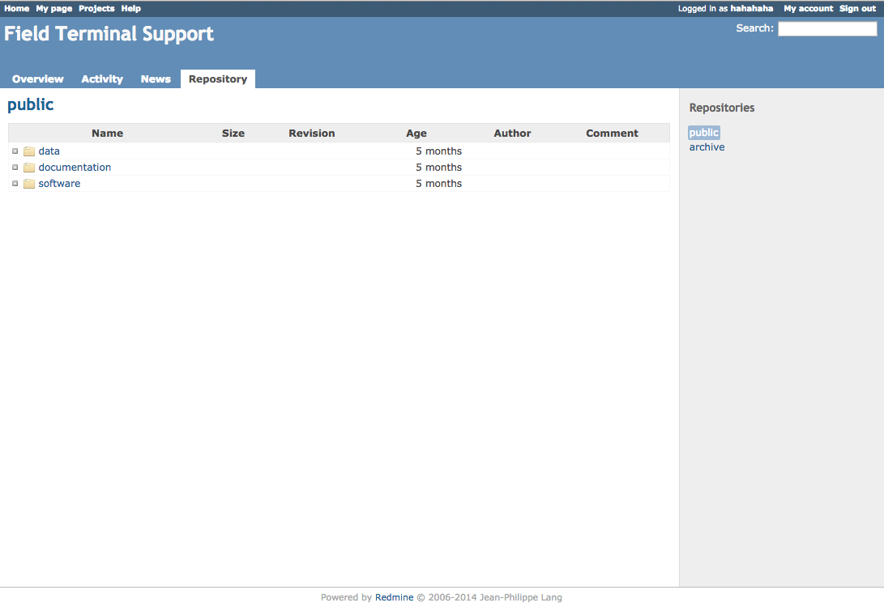

Figure 4-13: Screenshot of the repository tab

The Repository tab allows the customer to browse the project repository and view the latest updates.

You can expand a directory by clicking on.
You can also enter a directory by clicking on its name.
Clicking a revision number will display the details of the commit.

To browse the repository at a given revision, enter the revision number in the upper-right field and hit “Enter”.

The repository contains the following three directories:

Directory | Description
Data | This is the location where data will reside (e.g., ancillary, auxiliary, and Gridded Intermediate Products (IPs)).
Documentation | This is the location where all documentation will reside (e.g., antenna specifications, data formats, etc.)
Software | This is the location where software will reside (e.g., RT-STPS, ADL, etc.)

Manual Downloads

Data, documentation, and software can be browsed via the “repository” tab by clicking on the directories.

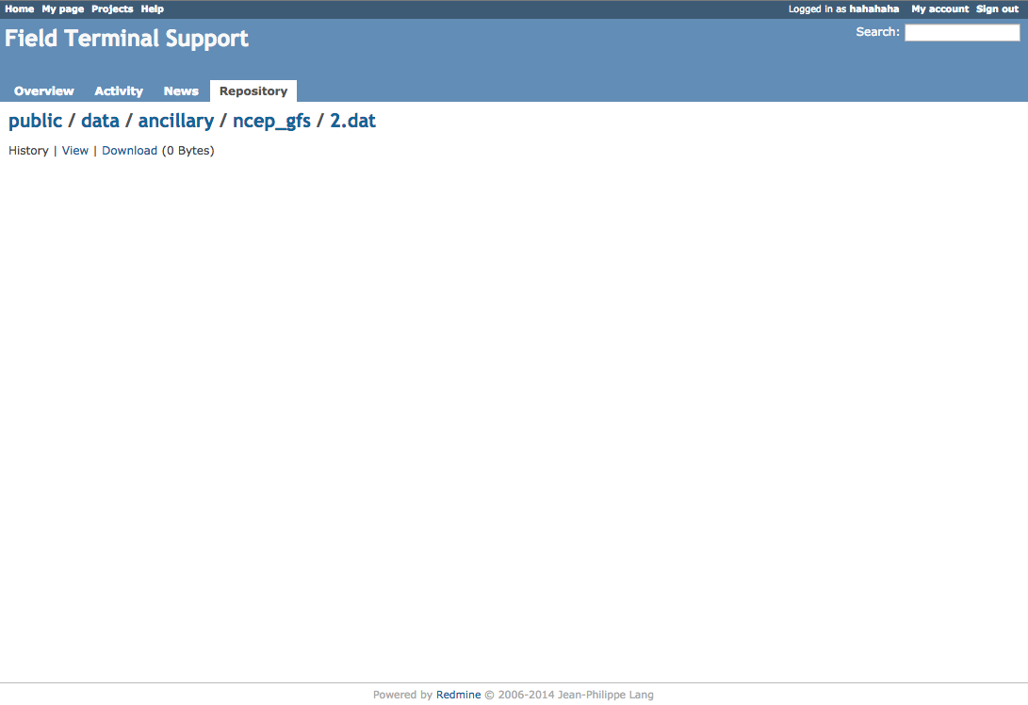
Figure 4-14: Screenshot of the page for manual downloads

To manually download a file, locate the file and click on it. This will bring you to a webpage with options to see the history, view the file, or download the file.

Automated Downloads

The FTS System provides manifest files that list the data available for customers to download. There is a master manifest file (manifest_list.txt) that contains a list of all directory manifest files located at: https://fts.jpss.noaa.gov/projects/fts/repository/raw/manifest_list.txt

For example, if the manifest list.txt file contains the following:

data/ancillary/fnmoc_naaps/manifest.txt
data/ancillary/fnmoc_navgem/manifest.txt
data/ancillary/gmasi/manifest.txt
data/ancillary/ncep_gfs/manifest.txt
data/ancillary/polar_wander/manifest.txt
data/ancillary/static/manifest.txt
data/auxiliary/cris_correct_matrix/manifest.txt
data/auxiliary/hlm_monitoring/manifest.txt
data/auxiliary/lut/manifest.txt
data/auxiliary/mission_notices/manifest.txt
data/auxiliary/mission_schedules/manifest.txt
data/auxiliary/pct/manifest.txt
data/auxiliary/revnumber/manifest.txt
data/auxiliary/rsb_autocal_history/manifest.txt
data/auxiliary/tle/manifest.txt
data/gridded_IPs/lsa/manifest.txt
data/gridded_IPs/mli/manifest.txt
data/gridded_IPs/ndvi/manifest.txt
data/gridded_IPs/qst/manifest.txt
data/gridded_IPs/qst-lwm/manifest.txt
data/gridded_IPs/snow_ice_cover/manifest.txt
documentation/atbd/manifest.txt
documentation/cdfcb/manifest.txt
documentation/jpss_srs/manifest.txt
documentation/mdfcb/manifest.txt
documentation/npp_oad/manifest.txt
documentation/rf_icd/manifest.txt
software/RT-STPS/manifest.txt
software/adl/manifest.txt

then, the file list for Mission Notices can be obtained at the following location: https://fts.jpss.noaa.gov/projects/fts/repository/raw/data/auxiliary/mission_notices/manifest.txt

Which provides a list of files for that data type, e.g.:

data/auxiliary/mission_notices/Mission-Notice-AUX_cmn_20160728182002Z_20160728182002Z_ee00000000000000Z_-_c3s-_ops_all-_all.xml
data/auxiliary/mission_notices/manifest.txt
data/auxiliary/mission_notices/Mission-Notice-AUX_cmn_20160811125029Z_20160811125029Z_ee00000000000000Z_-_c3s-_ops_all-_all.xml
data/auxiliary/mission_notices/Mission-Notice-AUX_cmn_20160730140614Z_20160730140614Z_ee00000000000000Z_-_c3s-_ops_all-_all.xml
data/auxiliary/mission_notices/Mission-Notice-AUX_cmn_20160606171046Z_20160606171046Z_ee00000000000000Z_-_c3s-_ops_all-_all.xml
data/auxiliary/mission_notices/Mission-Notice-AUX_cmn_20160606164609Z_20160606164609Z_ee00000000000000Z_-_c3s-_ops_all-_all.xml
data/auxiliary/mission_notices/Mission-Notice-AUX_cmn_20160805171902Z_20160805171902Z_ee00000000000000Z_-_c3s-_ops_all-_all.xml

The FTS System website supports Wget and cURL to automatically download data.

Wget is a free utility for non-interactive download of files from the Web. It supports HTTP, HTTPS, and FTP protocols, as well as retrieval through HTTP proxies.

cURL is an open source command line tool and library for transferring data with URL syntax, supporting DICT, FILE, FTP, FTPS, Gopher, HTTP, HTTPS, IMAP, IMAPS, LDAP, LDAPS, POP3, POP3S, RTMP, RTSP, SCP, SFTP, SMB, SMTP, SMTPS, Telnet and TFTP. cURL supports SSL certificates, HTTP POST, HTTP PUT, FTP uploading, HTTP form based upload, proxies, HTTP/2, cookies, user password authentication (Basic, Plain, Digest, CRAM-MD5, NTLM, Negotiate and Kerberos), file transfer resume, proxy tunneling and more.

Search Function
At the top right-hand side of the website is a search box. Input search text and press enter to search.

Figure 4-15: Screenshot of the search box

Clicking on the word Search will immediately take you to the advanced search and results page. Notice the project chooser has followed, and there are checkboxes to limit search to specific types of entries. The checkboxes will be displayed only if the module is enabled at that project level.

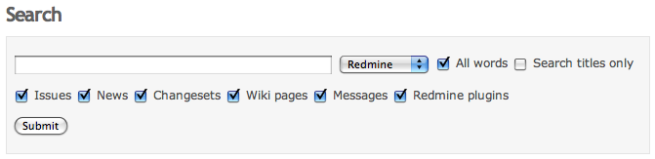

Figure 4-16: Screenshot of the advanced search page

Account Management

The “My account” link located toward the top-right corner of the screen lets you edit your account settings: last name, first name, email address, language.

If “Email notifications” is checked, you will receive notifications about any news/wiki events that occur.
If left unchecked, you will only receive notifications about the issues for which you are author or assignee, and about things you watch (e.g., issues, forums).

To change your password, type your old password and then your new password twice.

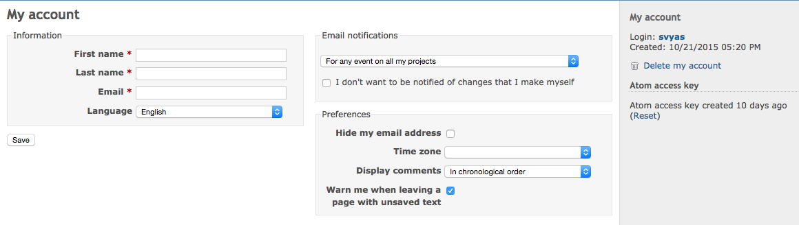
Figure 5-1: Screenshot of the account settings page

Additional Resources

End users or resellers may assemble their own systems from the components provided by the FTS System. Field Terminal Integrators interface with the FTS portal to obtain field terminal “building blocks” (ADL, as well as other relevant software and data), ancillary and auxiliary data, as well as mission notices and HRD link status information to be provided to their end users. Such users may then integrate the JPSS provided building blocks with their unique software to produce an HRD processing package for distribution to their end users.

The following entities are funded by JPSS to provide additional customer support.

NASA Direct Readout Laboratory (DRL)

The Direct Readout Laboratory (DRL) is a technology and information conduit for the Direct Broadcast (DB) community. With the support of the Joint Polar Satellite System (JPSS) and NASA Headquarters (HQ), the DRL develops and enables technologies that benefit the entire DB community. The DRL has developed the International Polar Orbiter Processing Package (IPOPP) for this purpose. The IPOPP processes science data and derivative products from the S- NPP, Aqua, and Terra missions and, in the future, the JPSS mission. IPOPP's real-time data processing capability maximizes the utility of Earth science data for real-time applications and decision-making. IPOPP is:
- freely available;
- portable to Linux x86 platforms;
- efficient to run on modest hardware;
- simple to install and easy to use;
- able to ingest and process overpasses of arbitrary size;
- able to produce core and regional value-added Environmental Data Record (EDR) products;
- highly configurable and scalable;
- capable of forward processing and reprocessing;
- compliant with mission formats.
For more information please go to:
https://directreadout.sci.gsfc.nasa.gov

University of Wisconsin CIMMS CSPP
As part of the University of Wisconsin - Madison Space Science and Engineering Center, Cooperative Institute for Meteorological Satellite Studies (CIMSS ) conducts cutting-edge research while fulfilling its three-part mission:
- Fostering collaboration among NOAA, NASA, and the University
- Serving as a center of excellence in weather and climate
- Training the scientists and engineers of today and tomorrow
CIMSS has developed the Community Satellite Processing Package (CSPP) for the Direct Broadcast (DB) community. CSPP supports DB users of both polar orbiting and geostationary satellite data processing and regional real-time applications through distribution of free open source software, and through training in local product applications.

The CSPP software for S-NPP is based on the Algorithm Development Library (ADL) developed by Raytheon and the JPSS project. This means that the CSPP software is the same software that runs in the operational processing facility at NOAA/NESDIS. CIMMS has packaged the software to run from the Linux command line in real-time direct broadcast mode, but have not changed the underlying processing software, algorithms, or data formats. The output files from the CSPP processing software are identical in naming, format, and structure to the corresponding files from NOAA/NESDIS. The native format for products is HDF5.

For more information please go to:
http://cimss.ssec.wisc.edu

Appendix A (Repository Directory Structure)

The top level of organization has been peer reviewed. The structure is flexible at lower levels to support changes based on feedback from the customer community.

The following table describes the repository directory structure:

Top level | Sublevel 1 | Sublevel 2 | Contents
Data | ancillary | fnmoc_naaps | Navy Aerosol Analysis and Prediction System files
Data | ancillary | fnmoc_navgem | Navy Global Environmental Model files
Data | ancillary | gmasi | Global Automated Multi-sensor Snow/Ice files
Data | ancillary | ncep_gfs | Global Forecast System files
Data | ancillary | polar_wander | Polar Wander (USNO)
Data | auxiliary | cris_correct_matrix | CrIS Correction Matrix
Data | auxiliary | hlm_monitoring | High Rate Data Link Monitoring Reports
Data | auxiliary | lut | Lookup Tables
Data | auxiliary | mission_notices | Mission Notices
Data | auxiliary | mission_schedules | Mission Schedules
Data | auxiliary | pct | Processing Coefficient Tables
Data | auxiliary | revnumber | Revolution Number file(s)
Data | auxiliary | rsb_autocal_history | RSB AutoCal History file(s)
Data | auxiliary | tle | Two-line Element Sets
Data | gridded_IPs | lsa | Land Surface Albedo files
Data | gridded_IPs | mli | Master Land Index files
Data | gridded_IPs | ndvi | Normalized Difference Vegetation Index
Data | gridded_IPs | qst | Quarterly Surface Type files
Data | gridded_IPs | qst-lwm | QST Land Water Mask files
Data | gridded_IPs | snow_ice_cover | Snow/Ice Cover
documentation | atbd | N/A | Public-released specs, ICDs, etc.
documentation | cdfcb | N/A | Public-released specs, ICDs, etc.
documentation | jpss_srs | N/A | Public-released specs, ICDs, etc.
documentation | mdfcb | N/A | Public-released specs, ICDs, etc.
documentation | npp_oad | N/A | Public-released specs, ICDs, etc.
documentation | rf_icd | N/A | Public-released specs, ICDs, etc.
Software | adl | N/A | ADL framework package(s), algorithm update package(s), and ADL data package (including static ancillary)
Software | RT-STPS | N/A | Real-time Software Telemetry Processing System

Appendix B (Abbreviations and Acronyms)

Acronym | Definition
ADL | Algorithm Development Library
CIMMS | Cooperative Institute for Meteorological Satellite Studies
CSPP | Community Satellite Processing Package (CSPP)
DB | Direct Broadcast
DPES | Data Products Engineering and Services
DRL | Direct Readout Laboratory
FTP | File Transfer Protocol
FTS | Field Terminal Support
GSFC | Goddard Space Flight Center
HRD | High Rate Data
HTTP | Hypertext Transfer Protocol
HTTPS | Hypertext Transfer Protocol Secure
IP | Intermediate Product
JPSS | Joint Polar Satellite System
LUT | Look Up Table(s)
NASA | National Aeronautics and Space Agency
NOAA | National Oceanic and Atmospheric Administration
RT-STPS | Real-time Software Telemetry Processing System

